**GCP vs AWS vs Azure**

#### <https://cloud.google.com/docs/get-started/aws-azure-gcp-service-comparison>

# <https://www.pluralsight.com/resources/blog/cloud/storage-showdown-aws-vs-azure-vs-gcp-cloud-comparison>

# <https://www.digitalocean.com/resources/article/comparing-aws-azure-gcp>

* Ss 47:29 gcp lec 5

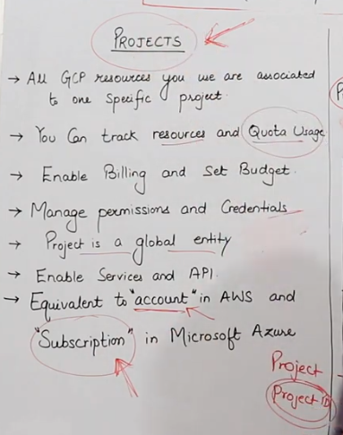

* Virtual Machine is called Compute Engine in GCP, EC2 (Elastic Compute Cloud) Instance in AWS and Virtual Machine in Azure

* Local SSD in Google is a temporary storage provided in a server. It is same as Ephemeral Disk in Azure and Instance Store in AWS

* GCP - Local SSD, AWS - Instance Store, Azure - Temporary or Ephemeral Disk

*Google is the only cloud provider that provides Custom Machine.

* Local SSD in Google is a temporary storage provided in a server. It is same as Ephemeral Disk in Azure and Instance Store in AWS.

*Google cloud keeps all the data and storage by default in encrypted form. AWS and Azure also provide encryption but there we have to select it manually.

*Google uses Open Source KVM hypervisor (kernel based and linux based). AWS uses Nitro. Azure uses Hyper V which is its own hypervisor.

*Google cloud has fast booting time among all cloud providers and least latency.

*Sustained use discount is only provided by google among all other cloud providers to attract customers.

* In AWS we call EC2, in Azure we call VM, in GCP we call VM instance.

*In google cloud, by default we only have a CLI interface. We have to select a User Experience checkbox while creating an O. S.

* In GCP, if you want to use any service, then it will ask you to firstly enable the API for it.

* In GCP it is called Persistent Disk, In AWS it is called Amazon Elastic Block Store (Amazon EBS), In Azure it is called Managed Disks.

* In GCP, we have a VPC Network. In AWS also it is called VPC, In Azure it is called Virtual Network.

* In GCP, the VPC Network is a global service. In AWS & Azure, it is a regional service.